Directions for service usage

Version 1.04

Changelog

Date | Change
12/11-2010 | Version 1.00.
7/12-2010 | Section included: 2.4 Header information and error handling
10/2-2011 | Section included: 2.5 Service call – creation of http(s) connection and receiving data
17/10-2011 | 1) Added section 3.1 and 3.2 on error handling for Tamper Token  2) Added section 5 on examples of service requests and responses  3) Added section 3.6 on example of MAC calculation of a file  4) Added section 3.7 on unused tokens  5) Added section 4.3 on date for placement of zip-file in the folder structure
Table of Contents
1.0 Introduction 4
2.0 General technical configurations 5
2.1 Login and password 5
2.2 End point 5
2.3 Connection test 5
2.4 Header information and error handling 5
2.5 Service call – creation of http(s) connection and receiving data 6
3.0 Tamper Token configurations 7
3.1 Error handling for Tamper Token Hent service 7
3.2 Error handling for Tamper Token Luk service 8
3.3 Mechanism for MAC generation 9
3.4 MAC API 9
3.5 MAC algorithm - figure 10
3.6 Example of MAC calculation 11
3.7 Handling unused tokens 11
4.0 SAFE configurations 13
4.1 Naming standards 13
4.2 Packing of files 13
4.3 Choice of date-folder for zip-file 14
5.0 Examples of Tamper Token and ROFUS service request and reponse 16
5.1 TamperTokenHent 16
5.2 TamperTokenLuk 16
5.3 GamblerCheck for person number not registered in ROFUS 17
5.4 GamblerCheck for person number temporarily registered in ROFUS 18
5.5 GamblerCheck for person number indefinitely registeret in ROFUS 19

1.0 Introduction
The purpose of this document is to provide directions for service usage for the technical parts of the solution, including the License Holder’s data storage – SAFE, the security system Tamper Token and the Problem Gambler Register (LUR).

In each section is provided both general information for service usage and specific information for each part of the solution. The License Holder must conform to the requirements listed in this document.

2.0 General technical configurations

2.1 Login and password
Login and password for License Holder for connection to services will be provided during the connection process.

2.2 End point
The end point for each service will be communicated to License Holder during the connection process. First, the License Holder will be provided access to the test environment, secondly to the production environment.

2.3 Connection test
The Gambling Authority will provide test data for test of the answer from the end point. The data will be provided during the connection process.

2.4 Header information and error handling
Header and error information is handled identically for Tamper Token and LUR services. The purpose of including header information is to make it possible to follow request and response for a service call and to be able to report errors.

The header information is inserted in an any-element on each service and must comply with the format specified in the XSD-files for header information, which are found on the Gambling Authority’s website.

The following header information should be stated in a service request made by the License Holder:
- TransaktionsID: License Holder must generate a unique transaction id for the service call. The Gambling Authority recommends to follow the standard Universally Unique Identifier (UUID), where the id consists of 32 hexa decimals represented in 5 groups separated by dashes on the form 8-4-4-4-12. E.g.: 07B2A963-26C4-47E0-B517-C7059A598DA3
- TransaktionsTid: The time of transaction. The time must be stated on the form YYYY-MM-DDThh:mm:ss.sTZD, where YYYY is year, MM is month, DD is day, hh is hours, mm is minutes, ss is seconds, s is one or more digits for seconds, and TZD is the time zone represented as Z or +hh:mm or –hh:mm. E.g.: 2010-12-07T09:33:51.249+01:00.

The following header information is always stated in a service response:
- TransaktionsID: Same as above.
- TransaktionsTid: Same as above.
- ServiceID: The name of the called service.

The following header information is also returned in a service response, but is optional and is only returned when necessary.
- Fejl: Errors are reported when a request is not completed as expected.
  - FejlNummer: Id-number for the error.
  - FejlTekst: Description in text of the error.
  - Identifikation: Text-code for the error.
  - ServiceID: Same as above.
- Advis: Notifications are messages which are not errors. It could be a message explaining that the service call has been executed as expected.
  - AdvisNummer: Id-number for the notification.
  - AdvisTekst: Description in text of the notification.
  - Identifikation: Text-code for the notification.
  - ServiceID: Same as above.

Example, service request:
<soapenv:Envelope xmlns:soapenv="http://schemas.xmlsoap.org/soap/envelope/" xmlns:ser="http://services.lur.skat.dk">
<soapenv:Header/>
<soapenv:Body>
<ser:GamblerCreateRequest>
<Kontekst>
<ns1:HovedOplysninger xmlns:ns1="http://skat.dk/begrebsmodel/xml/schemas/kontekst/2007/05/31/">
<ns1:TransaktionsID>07B2A963-26C4-47E0-B517-C7059A598DA3</ns1:TransaktionsID>
<ns1:TransaktionsTid>2010-12-07T13:23:57.435+01:00</ns1:TransaktionsTid>
</ns1:HovedOplysninger>
</Kontekst>
<Actor>Spillemyndigheden</Actor>
<PersonInformation>
<PersonCPRNumber>111111-3333</PersonCPRNumber>
</PersonInformation>
<ExclusionStart>
<GameExclusionStartDate>2010-12-07</GameExclusionStartDate>
<GameExclusionStartTime>13:23:57</GameExclusionStartTime>
</ExclusionStart>
</ser:GamblerCreateRequest>
</soapenv:Body>
</soapenv:Envelope>

Example, service response:
<S:Envelope xmlns:S="http://schemas.xmlsoap.org/soap/envelope/">
<S:Body>
<ns3:GamblerCreateResponse xmlns:ns3="http://services.lur.skat.dk" xmlns:ns2="http://skat.dk/begrebsmodel/xml/schemas/kontekst/2007/05/31/">
<Kontekst>
<ns2:HovedOplysningerSvar xmlns="http://skat.dk/begrebsmodel/xml/schemas/kontekst/2007/05/31/">
<TransaktionsID>07B2A963-26C4-47E0-B517-C7059A598DA3</TransaktionsID>
<ServiceID>LUR_SPILLER_OPRET</ServiceID>
<TransaktionsTid>2010-12-07T13:44:43.510+01:00</TransaktionsTid>
<SvarReaktion>
<Advis>
<AdvisNummer>7</AdvisNummer>
<AdvisTekst>The person is registered as a gambler in the Ludomaniregister</AdvisTekst>
<Identifikation>
<IDText xmlns="" xmlns:ns5="http://skat.dk/begrebsmodel/xml/schemas/kontekst/2007/05/31/">LUR:SpillerIndberet.GamblerISReported</IDText>
</Identifikation>
</Advis>
</SvarReaktion>
</ns2:HovedOplysningerSvar>
</Kontekst>
</ns3:GamblerCreateResponse>
</S:Body>
</S:Envelope>

2.5 Service call – creation of http(s) connection and receiving data
The Danish Gambling Authority has developed an example of service calls to help the License Holders task of calling the webserivces. The example shows how one can (in Java and .Net) get webservice descriptions and call services by the use of http basic access authentication. Furthermore is shown how data can be received from the service. The service GamblerCheck is used in the example. The example does not have focus on construction of the request and parsing of the response.

The following to example files can be found under directions for service usage:
- Example in .Net: GamblerServiceExampleClient.cs
- Example i java: GamblerServiceExampleClient.java

3.0 Tamper Token configurations
This section contains descriptions of Tamper Token as a help for the Licence Holder. The section contains descriptions of the error process for Tamper Token and information on the MAC algorithm which the Licence Holder must build.

3.1 Error handling for Tamper Token Hent service

Below is an illustration of the proces for handling errors on TamperTokenHent.

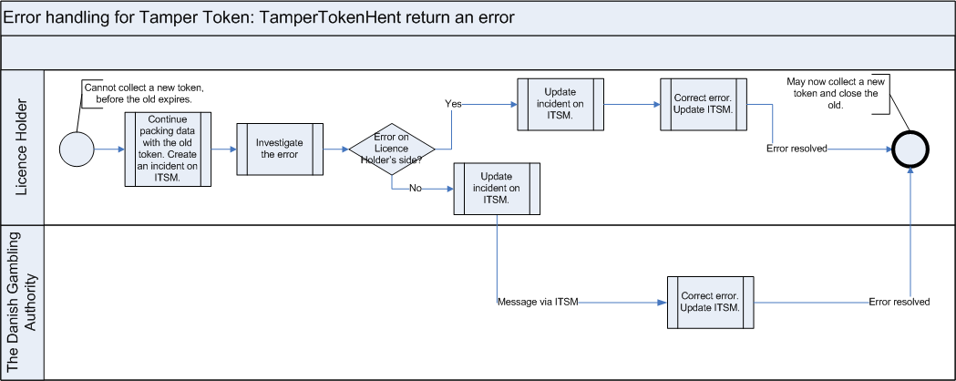
Process description

The start condition of the process is the situation, where a Licence Holder cannot collect a new token, before the token, which already is in use, expires.

The Licence Holder should continue to pack data with the old token, even though this token cannot be closed on time. The Licence Holder informs the Danish Gambling Authority through an incident reporting system (ITSM), if the token cannot be closed before it expires.

The Licence holder investigates whether or not they can correct the error themselves, or if there is an error on the Danish Gambling Authority’s side. The Licence Holder updates the incident via the incident reporting system (ITSM) when it has been identified whether the error is on the Licence Holders side or the Danish Gambling Authority’s side.

If the error is on the Licence Holder’s side, the Licence Holder should correct the error and update the incident via the incident reporting system (ITSM).

If the error is on the Danish Gambling Authority’s side, the Danish Gambling Authority will correct the error and update the incident via the incident reporting system (ITSM). The Licence Holder may now see a status via login on the incident reporting system (ITSM).

The Licence Holder may now collect a new token and close the old hereafter.

3.2 Error handling for Tamper Token Luk service

Below is an illustration of the process for handling errors on TamperTokenLuk.

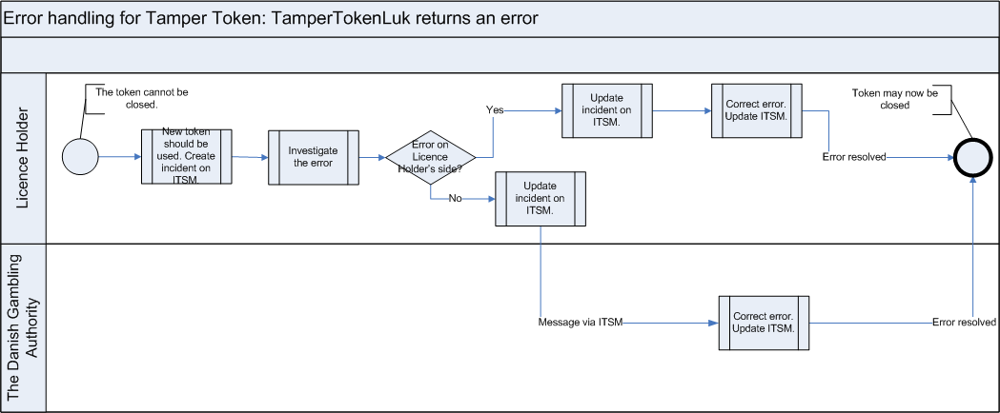

Process description

The start condition of the process is the situation where a Licence Holder cannot close the token on time before it expires.

At this point in the process, the Licence Holder will have collected a new token, since a new token must be collected before closing the existing. The Licence Holder should use the new token during the error handling process for TamperTokenLuk.

The Licence Holder should inform the Danish Gambling Authority via the incident reporting system (ITSM) on the error on TamperTokenLuk.

The Licence Holder investigates whether or not they can correct the error on their side, or whether or not the error is on the Danish Gambling Authority’s side. The Licence Holder updates the incident via the incident reporting system (ITSM).

If the error is on the Licence Holders side, the Licence Holder should correct the error and update the incident via the incident reporting system (ITSM).

If the error is on the Danish Gambling Authority’s side, the Danish Gambling Authority will correct the error and update the incident via the incident reporting system (ITSM). The Licence Holder may now see an updated status via login on the incident reporting system (ITSM).

The Licence Holder may now close the token.

3.3 Mechanism for MAC generation
The License Holder must build a mechanism to generate a MAC in the right way. It must match the way the Gambling Authority has built the same mechanism to ensure that MACs later can be compared. In the following sections it is described how to build this mechanism to generate MAC, including which API to apply.

The process for the mechanism that generates the MAC for a token is illustrated in the figure on page 10.

The 5 points on the figure is described in the following:
Ad 1. License Holder activates the service operation TamperTokenHent and receives a new TamperTokenID and a key, Key, which must be used for MAC generation for the first standard record file for the new Token.
Ad 2. When a new standard record file is generated, a MAC is generated of this record in near real time.
Ad 3. The generated MAC is now the new Key for the MAC generation.
Ad 4. After the MAC generation the present standard record file is added to a ZIP file for the present token.
Ad 5. When a token is closed, typically after the time interval which is given in the response from the service operation TamperTokenHent, the service operation TamperTokenLuk is activated with ID for the Token which should be closed, the latest generated MAC and the identification of the License Holder.

3.4 MAC API
For generation of MACs the class SecretKeySpec from Java 1.6 must be applied. Below is presented an example of how the code can look for the step “Generate MAC for standard record file using KEY”.

The argument key is either the key from the service operation TamperTokenHent or the MAC from a previous file and InputStream contains the data from a standard record, for which to generate a MAC.

Example:
public String getMAC(String key, InputStream input) throws TamperTokenException {
try {
Mac mac = Mac.getInstance("HmacSHA256");
byte[] byteKey = ByteArrayHandler.parseString(key);
SecretKeySpec keySpec = new SecretKeySpec(byteKey, "HmacSHA256");
mac.init(keySpec);
byte[] data = new byte[1024];
int read;
while((read=input.read(data)) > -1){
mac.update(data, 0, read);
}
return ByteArrayHandler.toString(mac.doFinal());
}
catch (Exception e) {
throw new TamperTokenException(e);
}
}

3.5 MAC algorithm - figure

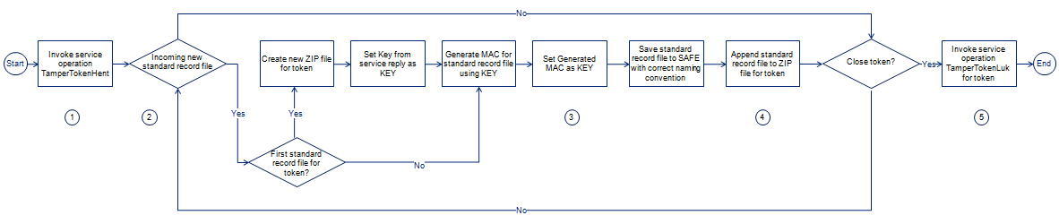

3.6 Example of MAC calculation
On the website of the Danish Gambling Authority, there is a link to the folder “Vejledning”: http://85.81.229.78/projects/SPIL/Vejledning/. In this folder is placed a file called TamperTokenTest3-2152.zip, which has been used below to give an example of calculation of MAC.

The example has been made for SpilCertifikatIdentifikation = TamperTokenTest3 and TamperTokenID = 2152.

The file TamperTokenTest3-2152.zip contains three files: TamperTokenTest3-2152-1.txt, TamperTokenTest3-2152-2.txt and TamperTokenTest3-2152-E.txt. A start MAC is retrieved by the serviceoperation TamperToeknHent, and it is shown below as TamperTokenStartMAC. Following this are shown the intermediate MACs, which is calculated on each file. The MAC from the last file is reported by the serviceopeartion TamperTokenLuk in the element TamperTokenMAC.

TamperTokenStartMAC = fb99919c20c57b01a1ab37fdc576f75a
MAC of file TamperTokenTest3-2152-1.txt = 148f1bc4bfe2be67cfed691f6a703ed90e780f45faab665b5c86a3c8346ad056
MAC of file TamperTokenTest3-2152-2.txt = a79953be54a71069a07d2d7c63566daaab221de984d93c36ae8c7b26d149df90
MAC of file TamperTokenTest3-2152-E.txt = 1b14a1da76568ab3b96bc64bb7ee02e846fbd7711e3ce40f477b0c66a0663016
TamperTokenMAC = 1b14a1da76568ab3b96bc64bb7ee02e846fbd7711e3ce40f477b0c66a0663016

3.7 Handling unused tokens
In the case where Licence Holder has used the service TamperTokenHent to retrieved a token, where it later appears that the token should not be used anyway, then the Licence Holder may close this token again by using the serviceoperation TamperTokenLuk and let the field TamperTokenMAC (which normally contains the calculated MAC) contain the string ”empty”. Such a service request will look as follows:

<soapenv:Envelope xmlns:soapenv="http://schemas.xmlsoap.org/soap/envelope/" xmlns:ns="http://skat.dk/begrebsmodel/2009/01/15/">
<soapenv:Header/>
<soapenv:Body>
<ns:TamperTokenAnvend_I>
<ns:Kontekst>
<ns1:HovedOplysninger xmlns:ns1="http://skat.dk/begrebsmodel/xml/schemas/kontekst/2007/05/31/">
<ns1:TransaktionsID>895ffb40-9f4a-11e0-8264-0800200c9a66</ns1:TransaktionsID>
<ns1:TransaktionsTid>2011-10-15T18:41:30.054+01:00</ns1:TransaktionsTid>
</ns1:HovedOplysninger>
</ns:Kontekst>
<ns:TamperOperationValg>
<ns:TamperTokenLuk>
<ns:TamperTokenID>2112</ns:TamperTokenID>
<ns:SpilCertifikatIdentifikation>TamperTokenTest3</ns:SpilCertifikatIdentifikation>
<ns:TamperTokenMAC>empty</ns:TamperTokenMAC>
</ns:TamperTokenLuk>
</ns:TamperOperationValg>
</ns:TamperTokenAnvend_I>
</soapenv:Body>
</soapenv:Envelope>

This way of handling unused tokens gives the Licence Holder the possibility for parallel SAFEs, such that the Licence Holder may retrieve two tokens in parallel and use one for the primary SAFE and the other for the secondary SAFE. The secondary token will only be used in the case where an error occurs on the primary SAFE, however, the Licence Holder must still remember to close the token before it expires and retrieve a new.

4.0 SAFE configurations
For the Gambling Authority to find and get the right data on SAFE, certain configurations must be in place in relation to naming and packing of files.

4.1 Naming standards
Naming and structure of folders on SAFE can be found in the document Folder structure on SAFE on www.spillemyndigheden.dk.

All files on SAFE must follow the naming standard provided below. This applies both to standard record files and zip files.

Standard record files must be named: SpilCertifikatIdentifikation-TamperTokenID-SequenceInToken.txt.
The Zip files must be named: SpilCertifikatIdentifikation-TamperTokenID.zip.

Here is:
SpilCertifikatIdentifikation: Text string provided by the Gambling Authority to the License Holder during the connection process.
TamperTokenID: Identification of each tamper token which is received by calling the service operation TamperTokenHent in the service TamperTokenAnvend.
SequenceInToken: A serial number, running from 1 and ended with E for ”End” (1, 2, 3,…,E) to indicate the sequence of which each standard record is included in the MAC algorithm for each token. It is the License Holders responsibility to build a mechanism for generation of the sequence.

Example:
If SpilCertifikatIdentifikation=12345, TamperTokenID=67890 and SequenceInToken=3 for a specific standard record file, the standard record file must have the following name 12345-67890-3.txt. The zip-file which contains this standard record must have the file name 12345-67890.txt.

4.2 Packing of files
To save disk space for the License Holder and to simplify the transfer of files, the standard record files must be zipped in a continuous process when they appear on SAFE. How they should be zipped is explained in the following.

- When the standard record files for a token arrives, the following should happen: The MAC algorithm is run on each file as described earlier in the document.
- The standard record is saved in the folder structure for the present token.
- The standard record is appended the the zip-file for the present token.
When the token is closed and all standard record files are added to the zip-file, the folder which matches the zip-file should be deleted. It is the License Holders task to build a mechanism to secure that these three steps are conducted correctly.

The following contains an example: On the figure below it is illustrated that the folder 2011-01-04 has two closed tokens which is associated to the zip-files: SpilCertifikatIdentifikation-TamperTokenID1.zip and SpilCertifikatIdentifikation-TamperTokenID2.zip, and one open token which is associated to SpilCertifikatIdentifikation-TamperTokenID3.zip. It can be seen that SpilCertifikatIdentifikation-TamperTokenID3.zip is open since there is both a zip-file and a folder structure with the same name. The standard records appearing continuously and is associated to token 3 should be saved in the folder SpilCertifikatIdentifikation-TamperTokenID3 and appended to SpilCertifikatIdentifikation-TamperTokenID3.zip. When token 3 is closed and all standard records are added to the zip file, the folder SpilCertifikatIdentifikation-TamperTokenID3 should be deleted.

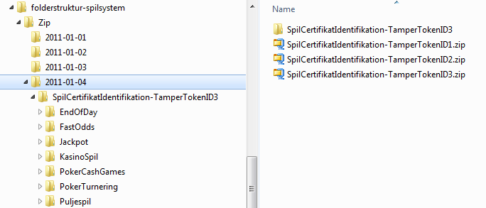

4.3 Choice of date-folder for zip-file
As described in the section above, the zip-file must be placed under level 3 in the folderstructure on SAFE. Level 3 is folders with dates, and the zip-file must be placed under the correct date.

The zip-file must be placed under the issue-date which is valid for the token. The issue-date is found in the response from the serviceoperation TamperTokenHent and is the first 10 characters of the element TamperTokenUdstedelseDatoTid.

In the example below is given the value 2011-10-16T15:21:19.221+02:00 in the element TamperTokenUdstedelseDatoTid. The zip-file, which is build using this token, must therefore be found on SAFE under the path folderstruktur-spilsystem/Zip/2011-10-16/.

<env:Envelope xmlns:env="http://schemas.xmlsoap.org/soap/envelope/">
<env:Header/>
<env:Body>
<ns:TamperTokenAnvend_O xmlns:ns="http://skat.dk/begrebsmodel/2009/01/15/">
<ns:Kontekst>
<HovedOplysningerSvar xmlns="http://skat.dk/begrebsmodel/xml/schemas/kontekst/2007/05/31/">
<TransaktionsID>895ffb40-9f4a-11e0-8264-0800200c9a66</TransaktionsID>
<ServiceID>TamperTokenAnvendService</ServiceID>
<TransaktionsTid>2011-06-25T18:41:30.054+01:00</TransaktionsTid>
</HovedOplysningerSvar>
</ns:Kontekst>
<ns:TamperTokenHent_O>
<ns:TamperTokenID>2149</ns:TamperTokenID>
<ns:TamperTokenStartMAC>91c5e2c0e033e3b18fc66bfa43bb08d4</ns:TamperTokenStartMAC>
<ns:TamperTokenUdstedelseDatoTid>2011-10-16T15:21:19.221+02:00</ns:TamperTokenUdstedelseDatoTid>
<ns:TamperTokenPlanlagtLukketDatoTid>2011-10-17T15:21:19.221+02:00</ns:TamperTokenPlanlagtLukketDatoTid>
</ns:TamperTokenHent_O>
</ns:TamperTokenAnvend_O>
</env:Body>
</env:Envelope>

5.0 Examples of Tamper Token and ROFUS service request and reponse

In the following are presented examples of service requests and responses for the services which the Licence Holder must use. The examples are thought of as help for the Licence Holder to understand the services to be used, but it is not the intention that the Licence Holder should build code base don the examples. For this purpose is refered to the service descriptions, XSD schemes and WSDL-files which are found the the Danish Gambling Authority’s website.

5.1 TamperTokenHent

Request:
<soapenv:Envelope xmlns:soapenv="http://schemas.xmlsoap.org/soap/envelope/" xmlns:ns="http://skat.dk/begrebsmodel/2009/01/15/">
<soapenv:Header/>
<soapenv:Body>
<ns:TamperTokenAnvend_I>
<ns:Kontekst>
<ns1:HovedOplysninger xmlns:ns1="http://skat.dk/begrebsmodel/xml/schemas/kontekst/2007/05/31/">
<ns1:TransaktionsID>895ffb40-9f4a-11e0-8264-0800200c9a66</ns1:TransaktionsID>
<ns1:TransaktionsTid>2011-06-25T18:41:30.054+01:00</ns1:TransaktionsTid>
</ns1:HovedOplysninger>
</ns:Kontekst>
<ns:TamperOperationValg>
<ns:TamperTokenHent>
<ns:SpilCertifikatIdentifikation>TamperTokenTest3</ns:SpilCertifikatIdentifikation>
</ns:TamperTokenHent>
</ns:TamperOperationValg>
</ns:TamperTokenAnvend_I>
</soapenv:Body>
</soapenv:Envelope>

Response:
<env:Envelope xmlns:env="http://schemas.xmlsoap.org/soap/envelope/">
<env:Header/>
<env:Body>
<ns:TamperTokenAnvend_O xmlns:ns="http://skat.dk/begrebsmodel/2009/01/15/">
<ns:Kontekst>
<HovedOplysningerSvar xmlns="http://skat.dk/begrebsmodel/xml/schemas/kontekst/2007/05/31/">
<TransaktionsID>895ffb40-9f4a-11e0-8264-0800200c9a66</TransaktionsID>
<ServiceID>TamperTokenAnvendService</ServiceID>
<TransaktionsTid>2011-06-25T18:41:30.054+01:00</TransaktionsTid>
</HovedOplysningerSvar>
</ns:Kontekst>
<ns:TamperTokenHent_O>
<ns:TamperTokenID>385</ns:TamperTokenID>
<ns:TamperTokenStartMAC>a06174fd062bb397894860bd5c20aa08</ns:TamperTokenStartMAC>
<ns:TamperTokenUdstedelseDatoTid>2011-06-25T18:47:04.481+02:00</ns:TamperTokenUdstedelseDatoTid>
<ns:TamperTokenPlanlagtLukketDatoTid>2011-06-26T18:47:04.481+02:00</ns:TamperTokenPlanlagtLukketDatoTid>
</ns:TamperTokenHent_O>
</ns:TamperTokenAnvend_O>
</env:Body>
</env:Envelope>

5.2 TamperTokenLuk

Request:
<soapenv:Envelope xmlns:soapenv="http://schemas.xmlsoap.org/soap/envelope/" xmlns:ns="http://skat.dk/begrebsmodel/2009/01/15/">
<soapenv:Header/>
<soapenv:Body>
<ns:TamperTokenAnvend_I>
<ns:Kontekst>
<ns1:HovedOplysninger xmlns:ns1="http://skat.dk/begrebsmodel/xml/schemas/kontekst/2007/05/31/">
<ns1:TransaktionsID>895ffb40-9f4a-11e0-8264-0800200c9a66</ns1:TransaktionsID>
<ns1:TransaktionsTid>2011-06-25T18:41:30.054+01:00</ns1:TransaktionsTid>
</ns1:HovedOplysninger>
</ns:Kontekst>
<ns:TamperOperationValg>
<ns:TamperTokenLuk>
<ns:TamperTokenID>385</ns:TamperTokenID>
<ns:SpilCertifikatIdentifikation>TamperTokenTest3</ns:SpilCertifikatIdentifikation>
<ns:TamperTokenMAC>2da9fe732840bc40f05eefbace7bf03fc36e141907a8d6ce7da329fa0f1bb25c
</ns:TamperTokenMAC>
</ns:TamperTokenLuk>
</ns:TamperOperationValg>
</ns:TamperTokenAnvend_I>
</soapenv:Body>
</soapenv:Envelope>

Response:
<env:Envelope xmlns:env="http://schemas.xmlsoap.org/soap/envelope/">
<env:Header/>
<env:Body>
<ns:TamperTokenAnvend_O xmlns:ns="http://skat.dk/begrebsmodel/2009/01/15/">
<ns:Kontekst>
<HovedOplysningerSvar xmlns="http://skat.dk/begrebsmodel/xml/schemas/kontekst/2007/05/31/">
<TransaktionsID>895ffb40-9f4a-11e0-8264-0800200c9a66</TransaktionsID>
<ServiceID>TamperTokenAnvendService</ServiceID>
<TransaktionsTid>2011-06-25T18:41:30.054+01:00</TransaktionsTid>
<SvarReaktion>
<Advis>
<AdvisNummer>0</AdvisNummer>
<AdvisTekst>Token is now closed</AdvisTekst>
<ServiceID>TamperTokenAnvendService</ServiceID>
</Advis>
</SvarReaktion>
</HovedOplysningerSvar>
</ns:Kontekst>
</ns:TamperTokenAnvend_O>
</env:Body>
</env:Envelope>

5.3 GamblerCheck for person number not registered in ROFUS

Request:
<soapenv:Envelope xmlns:soapenv="http://schemas.xmlsoap.org/soap/envelope/" xmlns:ser="http://services.lur.skat.dk">
<soapenv:Header/>
<soapenv:Body>
<ser:GamblerCheckRequest>
<Kontekst>
<ns1:HovedOplysninger xmlns:ns1="http://skat.dk/begrebsmodel/xml/schemas/kontekst/2007/05/31/">
<ns1:TransaktionsID>f0e33d70-9f4c-11e0-8264-0800200c9a66</ns1:TransaktionsID>
<ns1:TransaktionsTid>2011-06-25T19:33:41.002+01:00</ns1:TransaktionsTid>
</ns1:HovedOplysninger>
</Kontekst>
<PersonInformation>
<PersonCPRNumber>1110911013</PersonCPRNumber>
</PersonInformation>
</ser:GamblerCheckRequest>
</soapenv:Body>
</soapenv:Envelope>

Response:
<S:Envelope xmlns:S="http://schemas.xmlsoap.org/soap/envelope/">
<S:Body>
<ns3:GamblerCheckResponse xmlns:ns3="http://services.lur.skat.dk" xmlns:ns2="http://skat.dk/begrebsmodel/xml/schemas/kontekst/2007/05/31/">
<Kontekst>
<ns2:HovedOplysningerSvar xmlns="http://skat.dk/begrebsmodel/xml/schemas/kontekst/2007/05/31/">
<TransaktionsID>f0e33d70-9f4c-11e0-8264-0800200c9a66</TransaktionsID>
<ServiceID>LUR_SPILLER_SOEG</ServiceID>
<TransaktionsTid>2011-06-25T19:34:20.020+02:00</TransaktionsTid>
</ns2:HovedOplysningerSvar>
</Kontekst>
<ExclusionStatus>
<GamblerExclusionStatus>PersonIsNotRegistered</GamblerExclusionStatus>
</ExclusionStatus>
</ns3:GamblerCheckResponse>
</S:Body>
</S:Envelope>

5.4 GamblerCheck for person number temporarily registered in ROFUS

Request:
<soapenv:Envelope xmlns:soapenv="http://schemas.xmlsoap.org/soap/envelope/" xmlns:ser="http://services.lur.skat.dk">
<soapenv:Header/>
<soapenv:Body>
<ser:GamblerCheckRequest>
<Kontekst>
<ns1:HovedOplysninger xmlns:ns1="http://skat.dk/begrebsmodel/xml/schemas/kontekst/2007/05/31/">
<ns1:TransaktionsID>f0e33d70-9f4c-11e0-8264-0800200c9a66</ns1:TransaktionsID>
<ns1:TransaktionsTid>2011-06-25T19:40:41.002+01:00</ns1:TransaktionsTid>
</ns1:HovedOplysninger>
</Kontekst>
<PersonInformation>
<PersonCPRNumber>1110913016</PersonCPRNumber>
</PersonInformation>
</ser:GamblerCheckRequest>
</soapenv:Body>
</soapenv:Envelope>

Response:
<S:Envelope xmlns:S="http://schemas.xmlsoap.org/soap/envelope/">
<S:Body>
<ns3:GamblerCheckResponse xmlns:ns3="http://services.lur.skat.dk" xmlns:ns2="http://skat.dk/begrebsmodel/xml/schemas/kontekst/2007/05/31/">
<Kontekst>
<ns2:HovedOplysningerSvar xmlns="http://skat.dk/begrebsmodel/xml/schemas/kontekst/2007/05/31/">
<TransaktionsID>f0e33d70-9f4c-11e0-8264-0800200c9a66</TransaktionsID>
<ServiceID>LUR_SPILLER_SOEG</ServiceID>
<TransaktionsTid>2011-06-25T19:41:50.751+02:00</TransaktionsTid>
</ns2:HovedOplysningerSvar>
</Kontekst>
<ExclusionStatus>
<GamblerExclusionStatus>PersonIsRegisteredTemporarily</GamblerExclusionStatus>
</ExclusionStatus>
</ns3:GamblerCheckResponse>
</S:Body>
</S:Envelope>

5.5 GamblerCheck for person number indefinitely registeret in ROFUS

Request:
<soapenv:Envelope xmlns:soapenv="http://schemas.xmlsoap.org/soap/envelope/" xmlns:ser="http://services.lur.skat.dk">
<soapenv:Header/>
<soapenv:Body>
<ser:GamblerCheckRequest>
<Kontekst>
<ns1:HovedOplysninger xmlns:ns1="http://skat.dk/begrebsmodel/xml/schemas/kontekst/2007/05/31/">
<ns1:TransaktionsID>f0e33d70-9f4c-11e0-8264-0800200c9a66</ns1:TransaktionsID>
<ns1:TransaktionsTid>2011-06-25T19:44:41.002+01:00</ns1:TransaktionsTid>
</ns1:HovedOplysninger>
</Kontekst>
<PersonInformation>
<PersonCPRNumber>1110910017</PersonCPRNumber>
</PersonInformation>
</ser:GamblerCheckRequest>
</soapenv:Body>
</soapenv:Envelope>

Response:
<S:Envelope xmlns:S="http://schemas.xmlsoap.org/soap/envelope/">
<S:Body>
<ns3:GamblerCheckResponse xmlns:ns3="http://services.lur.skat.dk" xmlns:ns2="http://skat.dk/begrebsmodel/xml/schemas/kontekst/2007/05/31/">
<Kontekst>
<ns2:HovedOplysningerSvar xmlns="http://skat.dk/begrebsmodel/xml/schemas/kontekst/2007/05/31/">
<TransaktionsID>f0e33d70-9f4c-11e0-8264-0800200c9a66</TransaktionsID>
<ServiceID>LUR_SPILLER_SOEG</ServiceID>
<TransaktionsTid>2011-06-25T19:45:14.800+02:00</TransaktionsTid>
</ns2:HovedOplysningerSvar>
</Kontekst>
<ExclusionStatus>
<GamblerExclusionStatus>PersonIsRegisteredIndefinitely</GamblerExclusionStatus>
</ExclusionStatus>
</ns3:GamblerCheckResponse>
</S:Body>
</S:Envelope>

